Proposal to Install a Southern Railway Semaphore Signal at the Signal Box

Introduction

Billingshurst signal box is celebrating its 150th anniversary this year. It was installed at the museum following its removal from Billingshurst station about 10 years ago, and is now being opened more frequently due to the recruitment of new volunteers. Presently it is open on Wednesdays and Saturdays, plus additional weekend opening when there are special events. The box is kept locked when there is no volunteer in attendance.
The box is used to demonstrate the procedure of running trains by passing them along a route from signal box to signal box, and setting signals for the drivers accordingly. We obviously lack trains, signals and adjacent signal boxes to achieve this in reality although some progress has been made with the construction of a microprocessor simulator to mimic the movement of trains by controlling the lamps on the signal box track circuit diagram, and to simulate the bell code communications with an imaginary signaler in an adjacent signal box.
The signal box levers can all be operated, and frequently are especially by enthusiastic younger visitors, but other than a scale model signal in the box there is nothing to show the results of their efforts. Fortunately when the signal box was delivered to the museum, we were also provided with a signal removed from nearby, this dates from the Southern Railway era (1923-1947) and presently lies in the white pit area. We now propose installing this signal adjacent to the signal box and operating it from one of the signal levers, either mechanically or electrically. The signal is of the old semaphore type with a moving arm, this iconic type has been in use on the railways in various forms since the 1840s but is now almost completely obsolete and worthy of preservation.
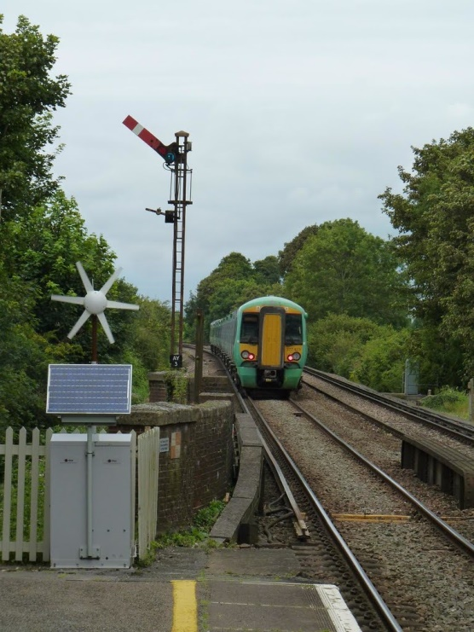
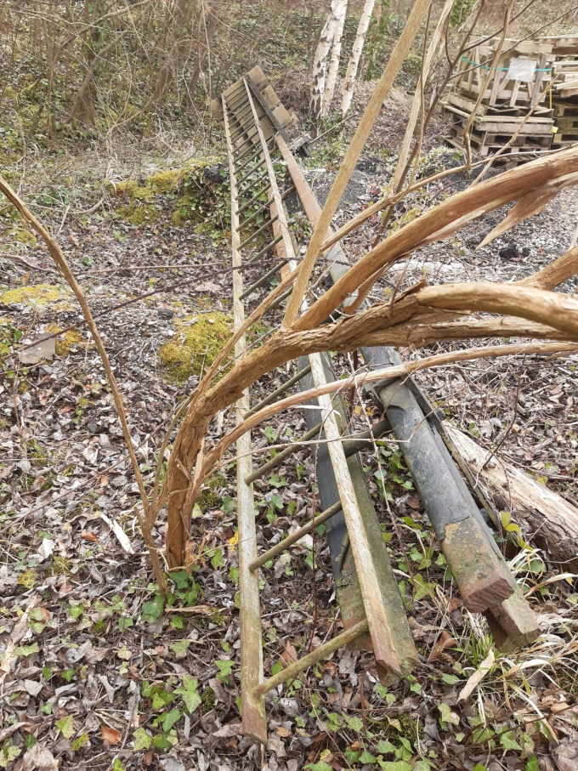
Similar signal removed from the Arun Valley line and delivered to the white pit area of the museum
Example of a Southern Railway semaphore signal at Amberley station prior to removal

